Procurement

Responsible Procurement – A Guide for our Supply Chain
Document code GD-QS-1000-01
Revision 01

Revision control
Rev No | Date issued | Prepared by | Approved by | Comments
00 | 27/9/2022 | Anne Goodwin | Craig Murphy | 1st Issue
01 | 13/10/2022 | Anne Goodwin | Craig Murphy | 2nd Issue
02 | 13/12/2022 | Anne Goodwin | Craig Murphy | 3rd Issue

Revision log
Rev No | Details
00 | 1st Issue
01 | 2nd Issue

Contents
1 Introduction 4
2 Aims and Objectives 4
3 Definitions and Abbreviations 5
4 Supply Chain Partner Requirements 5
5 High Risk Areas of Origin 6
6 Governance 7
7 Key Performance Indicators (KPI’s) 7
8 Grievance Procedure……………………………………………………………………………………………………………8

Introduction
John Sisk & Son (Holdings) Limited is committed to leading on and promoting responsible procurement in our business and are focused on maintaining a sustainable business that is both profitable and continues to uphold our core company values of Care, Integrity, and Excellence.
We recognise and accept our actions can have consequences on others and will strive to ensure that decisions taken regarding the procurement and engagement of any organisations, individuals, goods, or services are governed by integrating environmental, legal, social, and economic considerations into all stages of the procurement process.
We recognise and value the contribution our supply chain makes to the success of our projects and our business and understand that we need to work with our supply chain to achieve the ambitions which we have set for ourselves.
This guidance supports the objectives set out in our 2030 sustainability roadmap, to make a positive difference to the people, customers, clients, communities, and environments we impact and influence, and is aligned to the international standard for sustainable procurement (ISO20400).
This guidance provides specific information on our responsible procurement requirements and expectations for our Supply Chain, including specific expectations for materials sourced from high-risk areas of origin.

Aims and Objectives
To leverage our partners collective efforts to ensure Sisk meet and achieve the sustainability objectives set out in our 2030 Sustainability Roadmap. Robust, effective, and responsible procurement can positively influence and contribute across all 5 themes of our roadmap as shown in the diagram below.
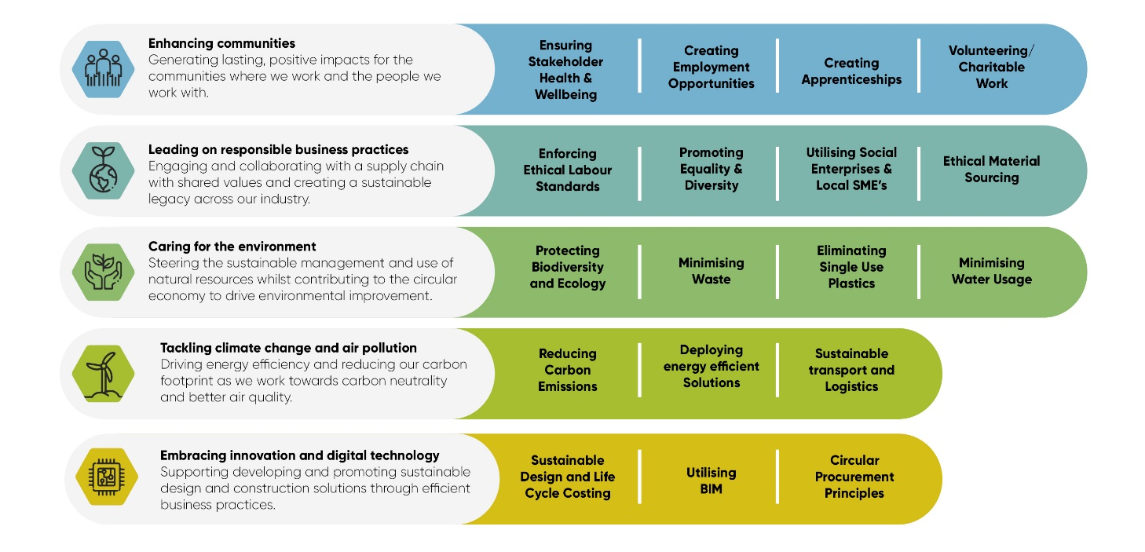

Definitions and Abbreviations
Abbreviations/Term | Meaning/Definition
SUP - Single Use Plastic | Plastics that are intended to be used only once before they are thrown away or recycled
BES6001 | Responsible sourcing of construction products
BS8902 | Responsible sourcing sector certification schemes for construction products
ISO20400 | International standard for sustainable procurement
FSC | Forest stewardship council
PEFC | Programme for the endorsement of forest certification
CoC | Chain of Custody
ILO | International labour organisation
CARES | UK certification authority for reinforcing steels
SBTI | Science based target initiatives
VOC | Volatile organic compounds
EPD | Environmental product declarations
HVO | Hydrotreated vegetable oil
BIM | Building Information Modelling
SME | Small or Medium sized enterprises
Social Enterprise | Business that works primarily to improve the lives of people
Micro Business | A business that operates with less than 10 people
VCSE | Voluntary, Charity or Social Enterprises
GWP | Global warming potential
VOC | Volatile organic compound
LED | Light emitting diode

Supply Chain Partner Requirements
The table below details the responsible procurement requirements for our supply chain partners, with mandatory requirements which must be complied with by all relevant parties, and those requirements which are encouraged, where we will procure with a preference for these requirements when all other aspects of delivery are equal.

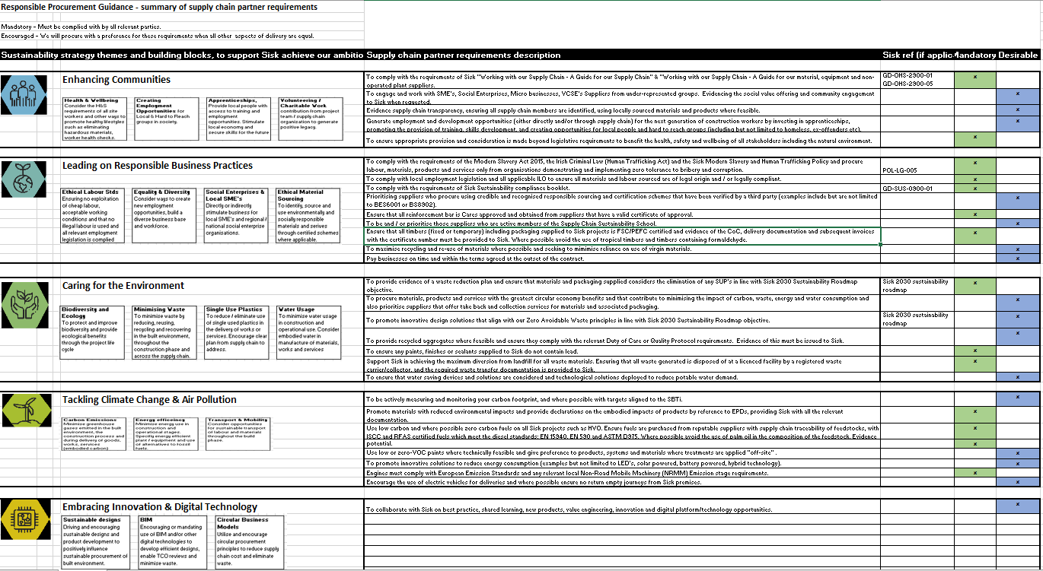

High Risk Areas of Origin
The below section details requirements for suppliers who are providing products or materials that are sourced from high-risk areas of origin.
High risk areas of origin are defined as countries or regions with a score of 49 or lower in the Transparency International’s Corruption Perception Index. Sisk expects suppliers to demonstrate responsible stewardship of their supply chain, even more so where products and materials are being procured from these defined high-risk areas of origin. This can be demonstrated through membership of, and active participation in certification schemes such as, but not limited to the Ethical Trading Initiative (ETI) or the TFT Responsible Stone Program.
Where products and materials are being procured from high-risk areas of origin, Sisk will need to understand more about the steps being taken to ensure that modern slavery and labour exploitation does not occur. You may be asked to provide Sisk with additional information (such as but not limited to the following):
- Percentage of the materials you are supplying (by value) that are sourced, manufactured, or supplied to Sisk from your organisation from an identified high-risk area of origin
- Evidence that regular supply chain audits are conducted (at least annually) either directly by your organisation or through third party auditors. This information should include:
- Labour standards in your supply chain operating in high-risk areas of origin
- Evidence of audits that have been undertaken, in the form of an audit extract or declaration
- Evidence of actions taken to address issues highlighted during the audit
- A copy of the template audit detailing the areas covered

Governance
To verify compliance with the responsible procurement requirements set out in this guidance, Sisk reserve the right to audit our supply chain partners. In this instance, you will be required to provide the relevant documentary evidence as requested by Sisk. The details of these requirements will be communicated by Sisk at pre-appointment and by provision of this guidance document in tender documents.
Where instances of non-compliance to the requirements are identified, a non-conformance report (NCR) will be raised by Sisk to the supply chain partner in question for appropriate action.

Key Performance Indicators (KPI’s)
The Responsible Procurement performance of our strategic supply chain partners will be tracked and measured against a standard suite of Key Performance Indicators which are in line with the targets set out in our 2030 Sustainability Roadmap. These KPI’s include but are not necessarily limited to the metrics below.

Area | Unit | Target
Sustainable timber | % Sourced | 100%
Concrete – transition to net zero concrete | % Sourced | 30% by 2025  50% by 2030  100% by 2050
Reinforcement – transition to net zero steel | % Sourced | 50% by 2030  100% by 2050
HVO Fuel (hydrotreated vegetable oil) | % Sourced | 100%
Engagement with Social enterprises | % Spend | 20% increase year on year

Grievance Procedure
Sisk are committed to conducting our business with honesty and integrity and have a Speak Up Policy (ref POL-LG-004) in place that covers all employees, consultants, contractors, and agency workers. A copy of the policy can be provided upon request.
Should there be a circumstance where you would like to raise any concerns anonymously there is a Speak Up hotline run by Navex Global/Ethics on the following numbers: -
- Ireland +353 1800 851 140
- United Kingdom & Northern Ireland +44 0808 1965 702
- Netherlands +31 0800 0235041
- Sweden +46 020 88 16 05
Alternatively via e-mail siskmobile@ethicspoint.com or via a secure website at https://secure.ethicspoint.eu/domain/media/en/gui/106425/index.html

